Creating your AWS Student Account

1. If you have already created an AWS account with your SMU email, go to step 9.
2. Otherwise, you have to create your AWS account first.   
   Go to: <https://aws.amazon.com>
3. Click “Create a Free Account”

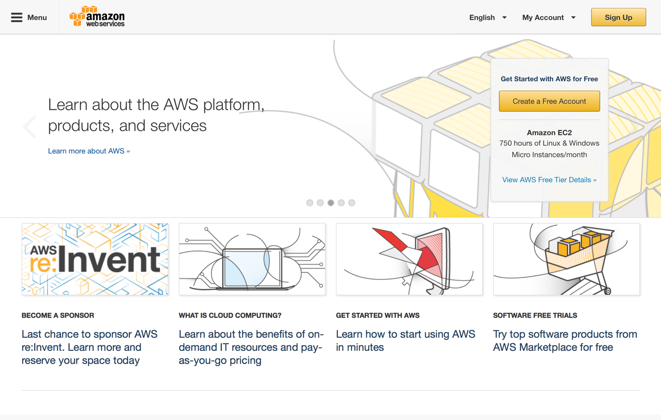

1. Enter your smu email: <your-id>.smu.edu.sg  
   Select “I am a new user” and click “Sign in using our secure server”

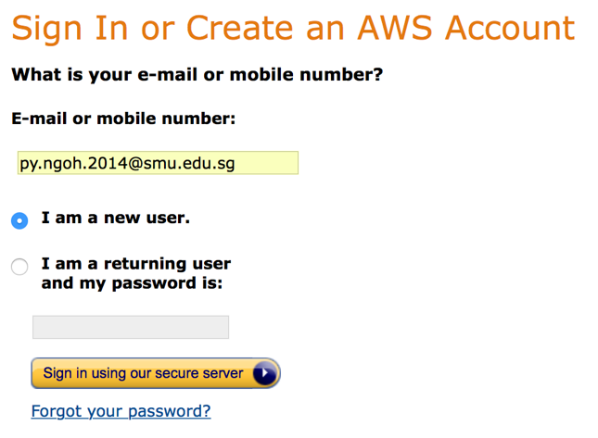

1. Fill up login credentials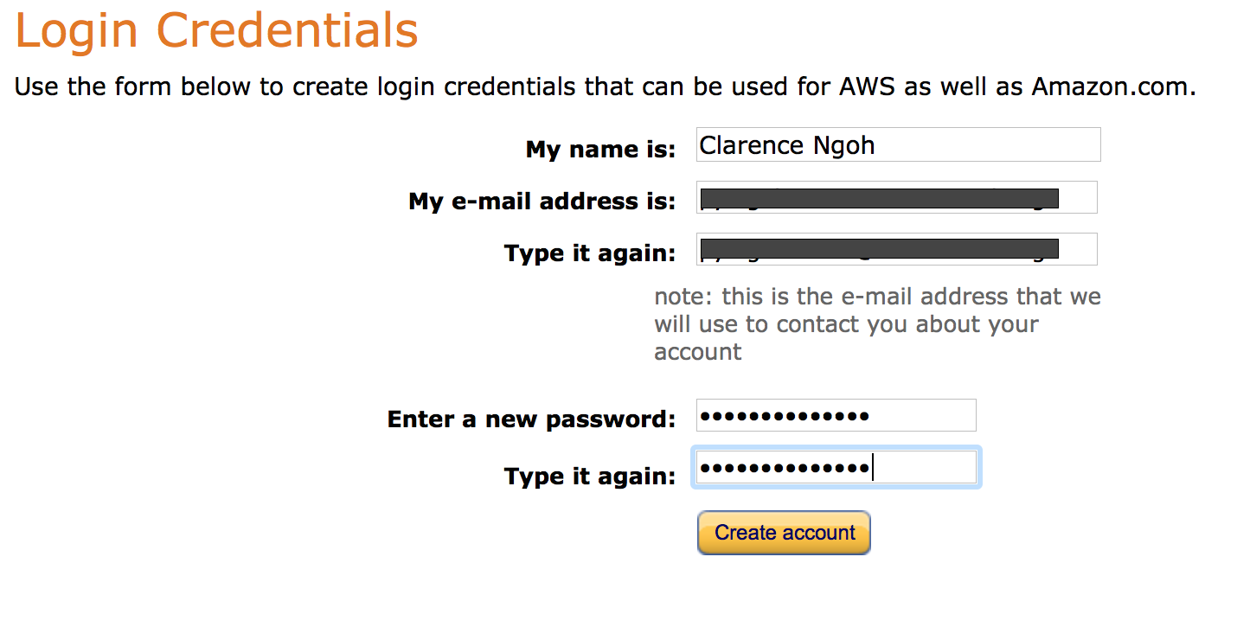
2. Enter credit information. Don’t worry, we will be getting free credits so you won’t have to use your own cash.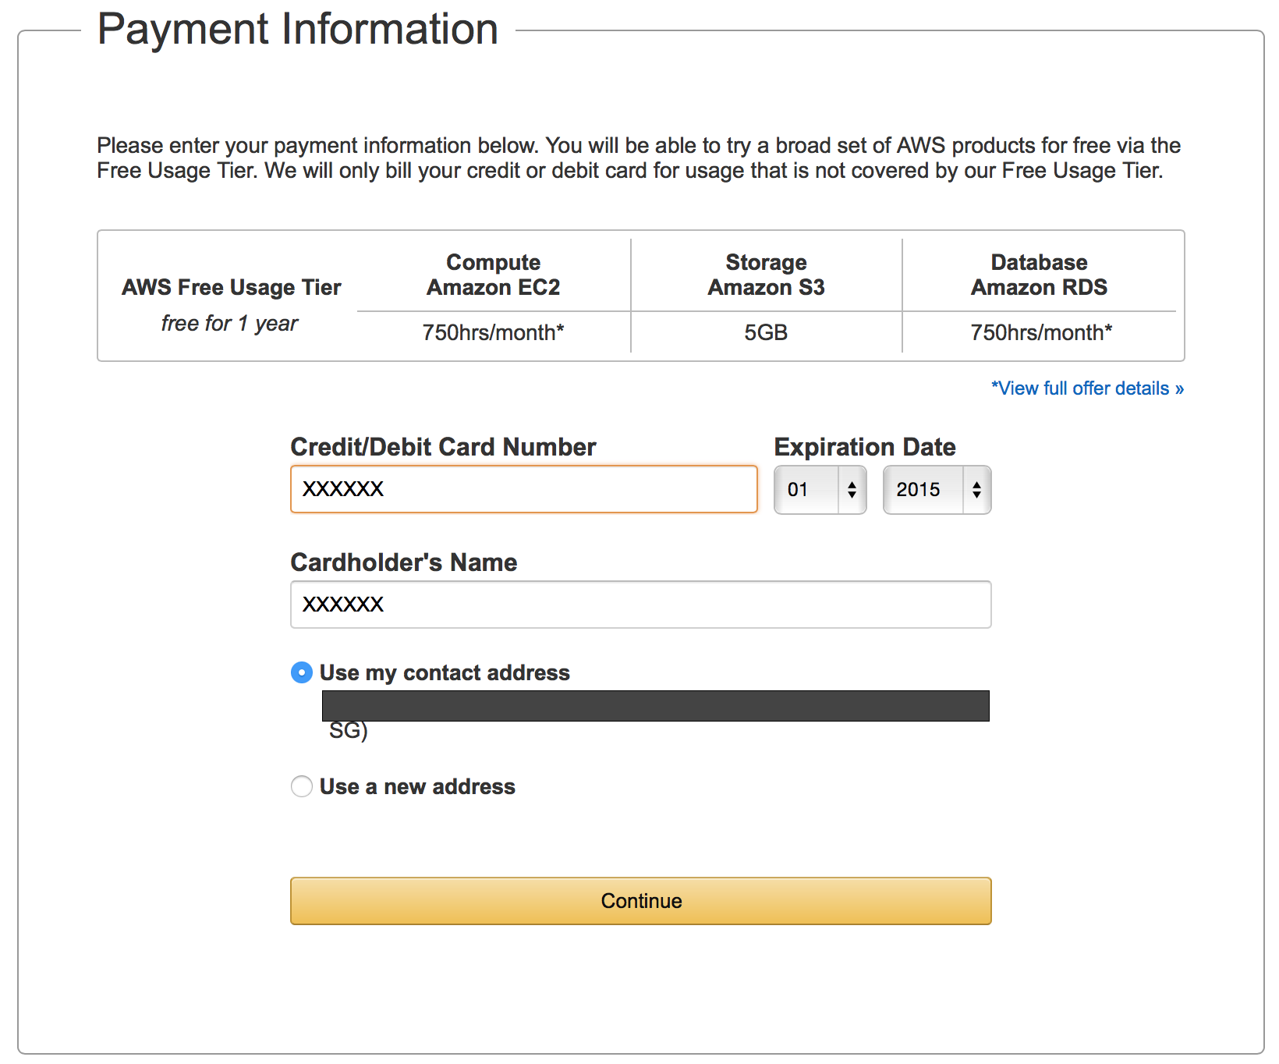
3. Enter your phone number for verification, you will receive a call and be prompted to key in a PIN on your keypad.

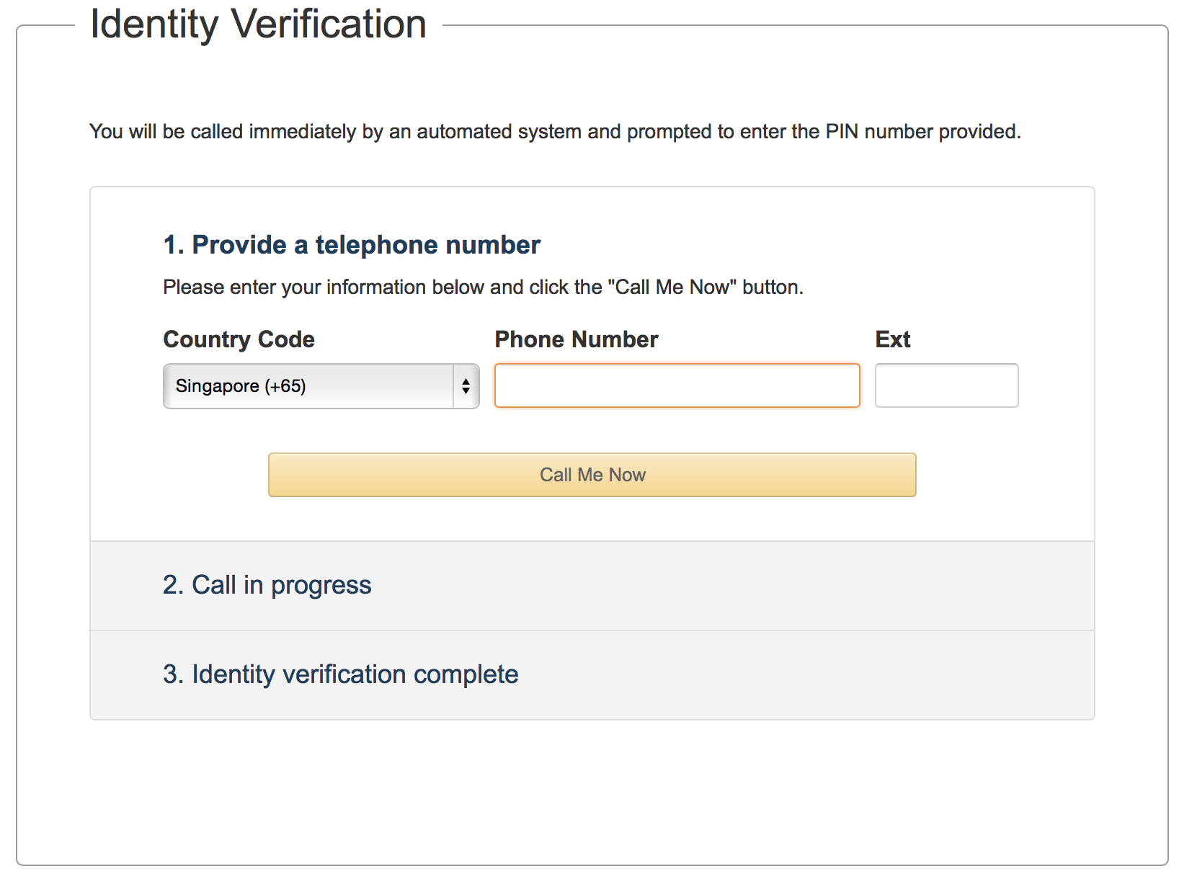

1. Choose “Basic (Free)”

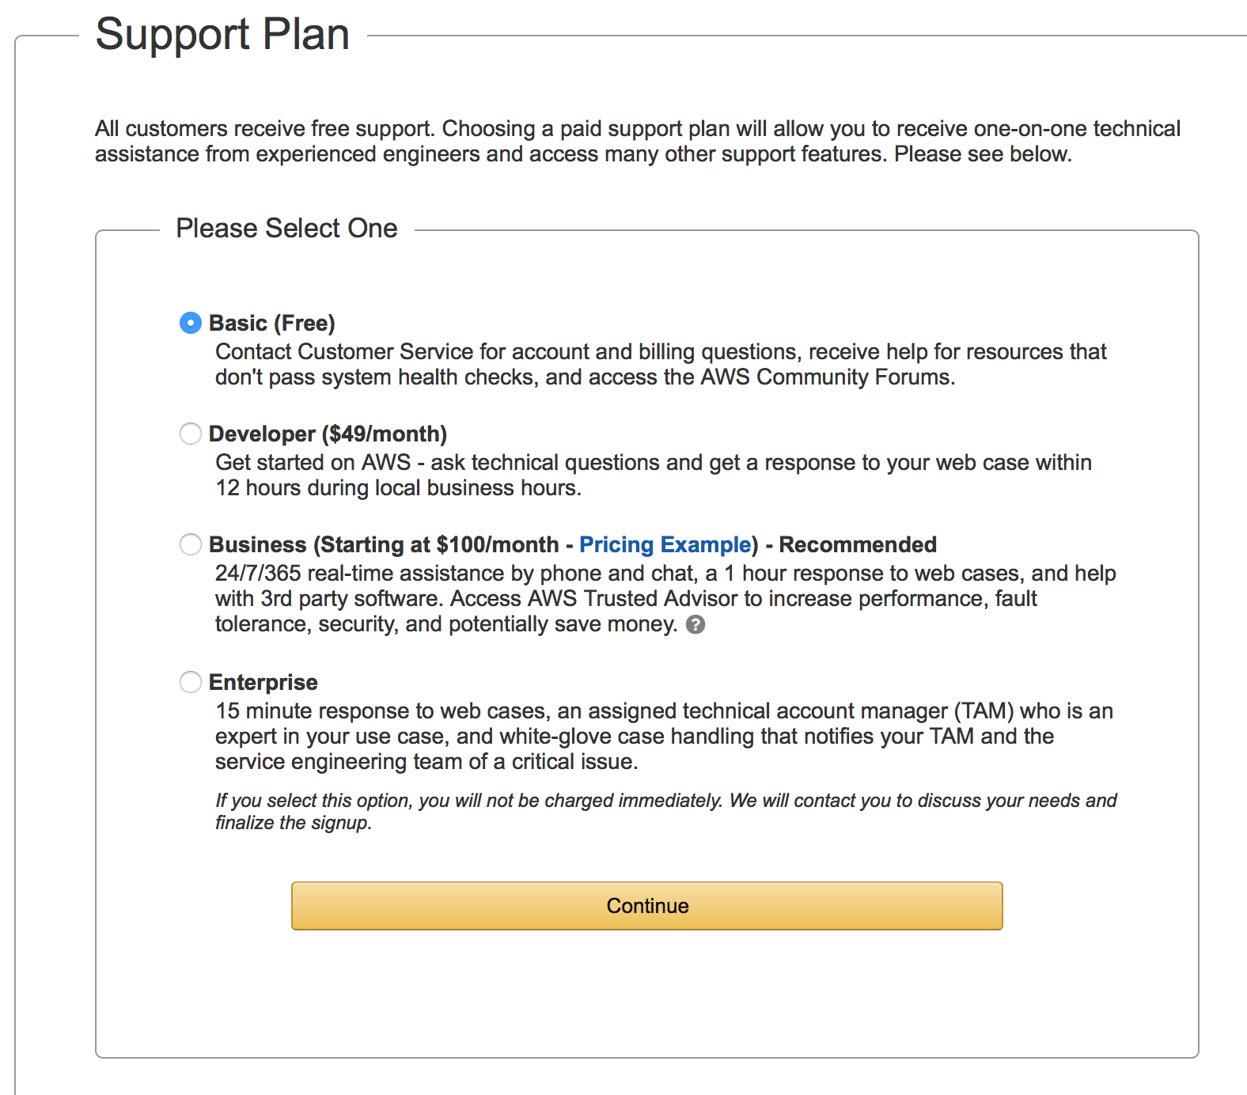

1. Now that you have an account, you will need to register it as a student account.
2. Go to: <http://aws.amazon.com/education/awseducate/>
3. Click “Apply Now”

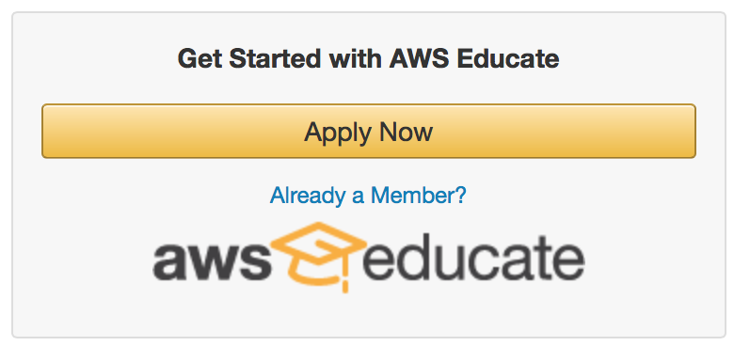

1. Click “Apply for AWS Educate for Students”

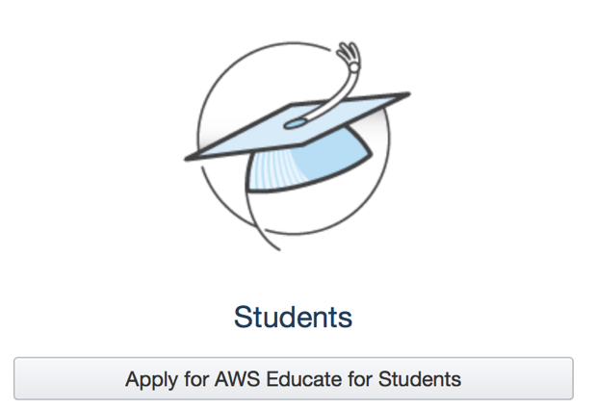

1. Choose “Student”

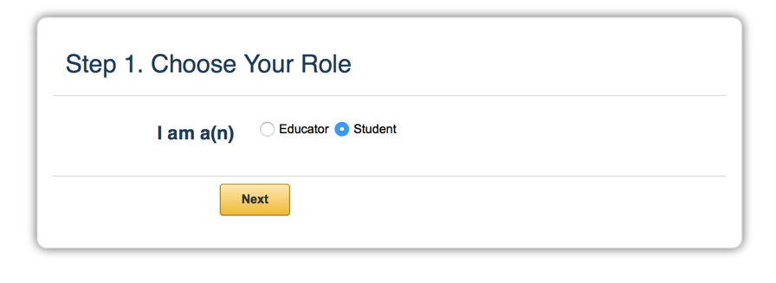

1. Fill out the application form as follows.

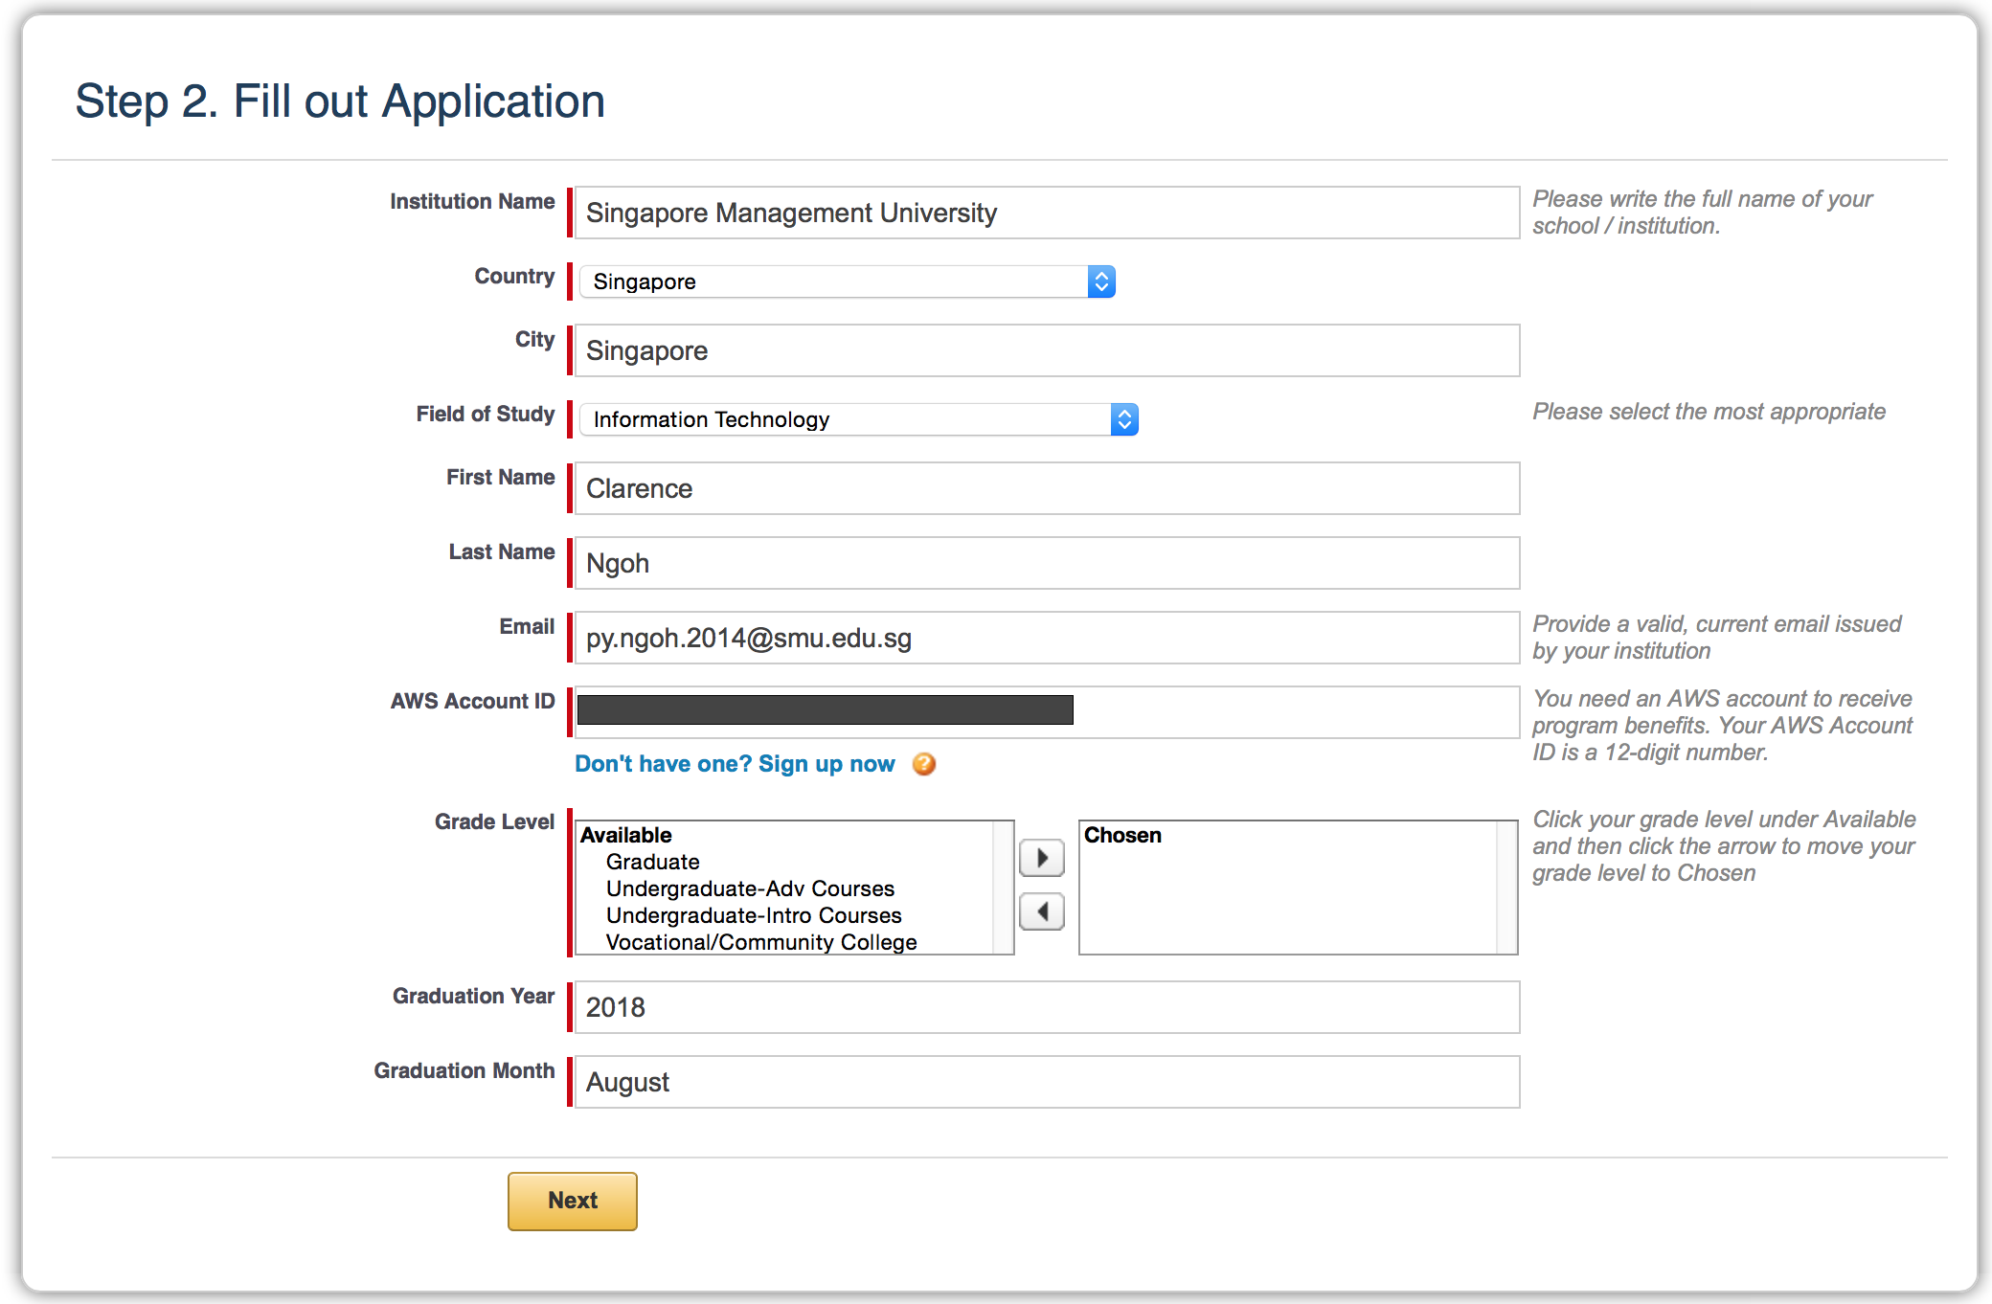

1. To retrieve your AWS Account ID, go back to <https://aws.amazon.com> and click “Account Settings”. This requires you to be logged in. 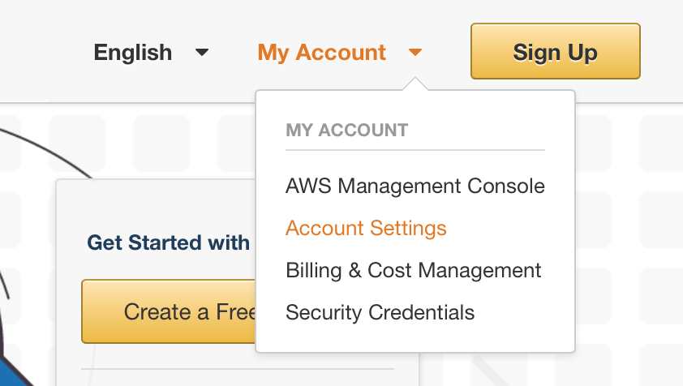
2. Your Account ID can be found here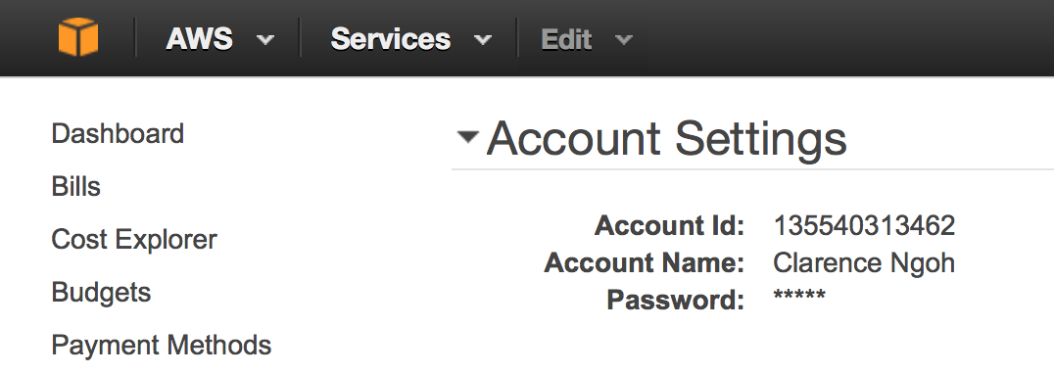
3. You may be required to verify your email address. Look for the verification code at your SMU email account.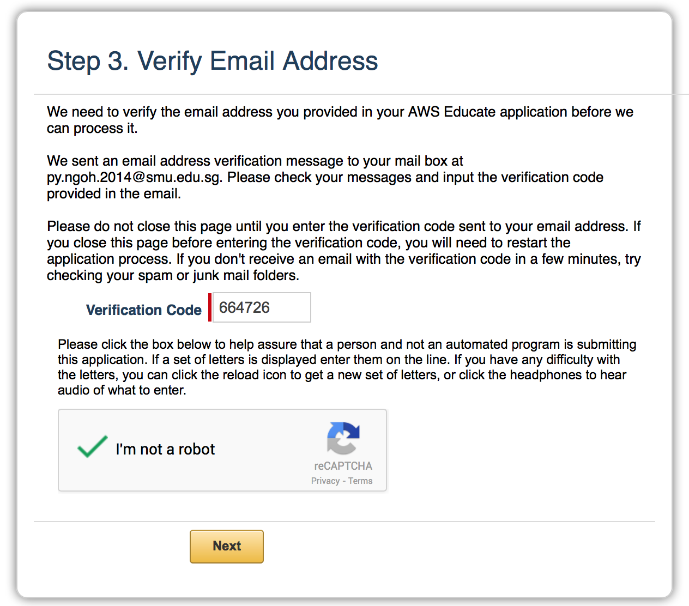
4. Your application will now be processed! This will take ~1 day.

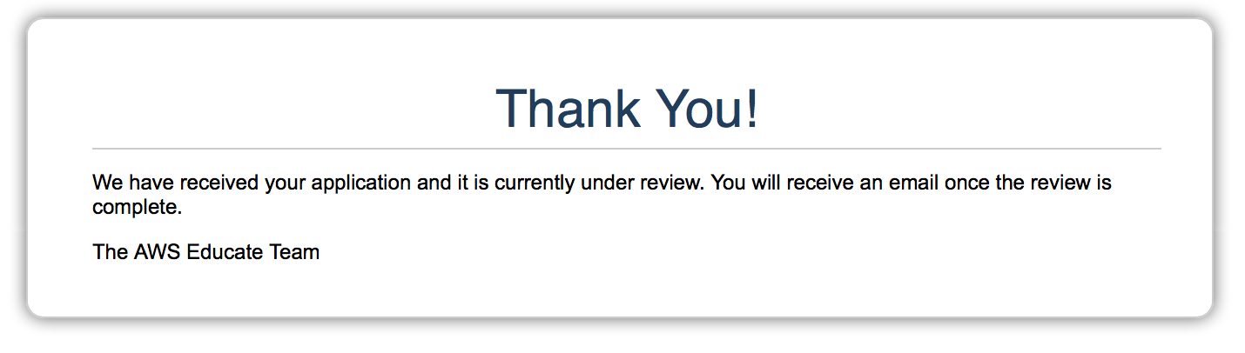

1. When your application is approved, you will receive and email notification.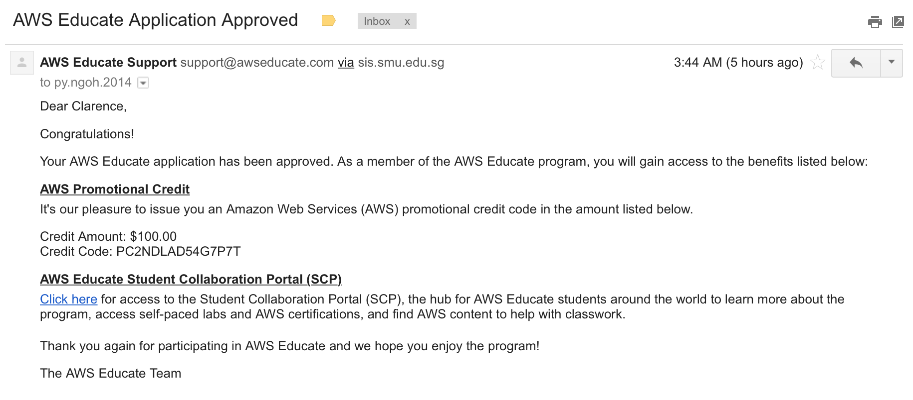
2. Finally, you need to redeem your credits. You may do so at the “Billing and Cost Management” page.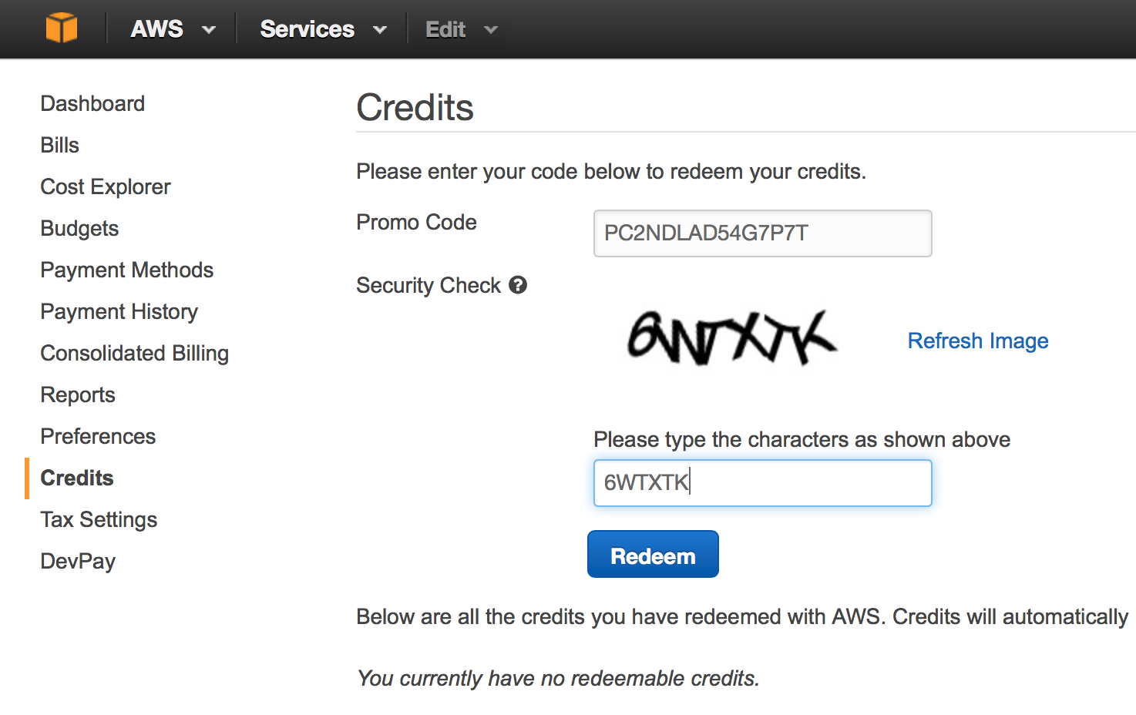
3. And you’re done! Enjoy your credits!